

Hospital Management System

* **Prepared By -**

**Abhishek Tyagi**

**XII Science**

**Login Form:**

This form will match the user name and password with the values in the login table. If user name and password match with the values in the login table then the login form will be closed and the master form, i.e. frmMDI gets opened. If the user name and password do not match with the values in the login table, then a message dialog box pops up, informing that either the user name or password is wrong.

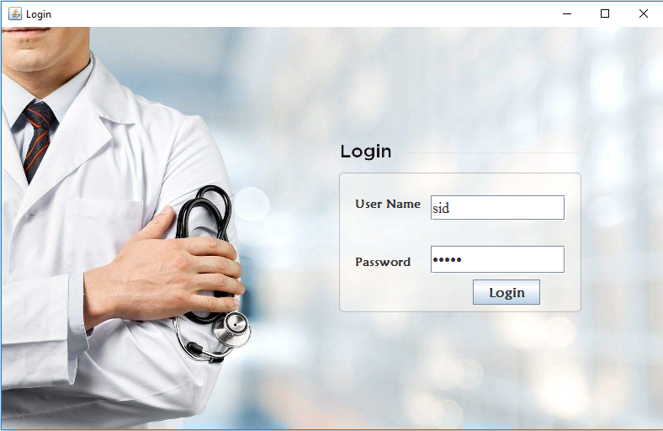

**Login Table:**

The user name and password are saved here. If the user name and password values entered by the user match with any of the record currently saved in the table then the login form allows the access to the master form i.e. frmMDI form. The password or user name can be updated by database administrator.

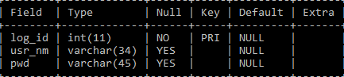

**Main form:**

The master form is a form through which we can access our entire software program. This form has two menu options - The first menu option, i.e. **Masters** contains all the master forms and the second menu option, i.e. **Search** has all the search form which relates with the respective master form. If any menu item from master or search menu clicked then that particular form gets opened.



**Patient Details:-**

This master form takes the patient details like Name, ID, Address, Date of Arrival, Diagnostic Information, preferred Room Type etc. and registers the new patient in the database of the hospital and can even update some information if necessary. Every patient has a unique Id which is auto-generated and is assigned as a primary key. We can easily navigate to insert, update, and delete record by clicking on the respective buttons.

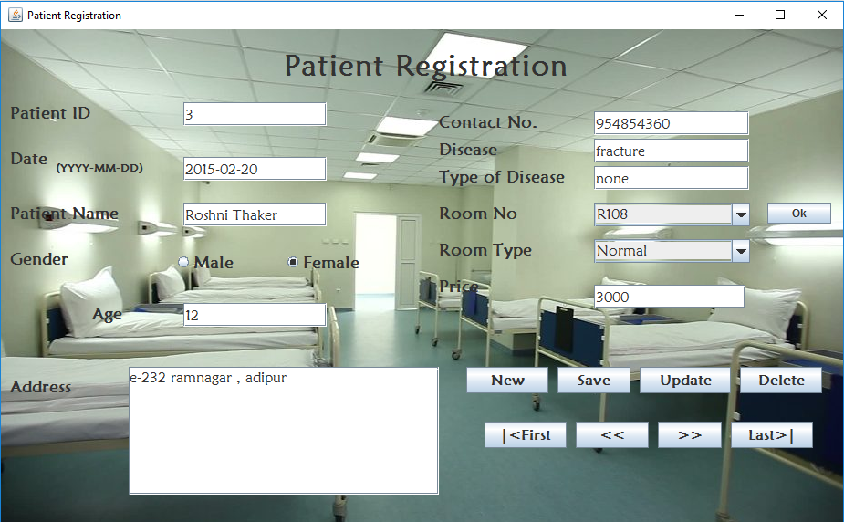

**Patient Details Table:**

All the values entered with the help of master form are saved here and any manipulation like deleting or updating value will change the value in this table.

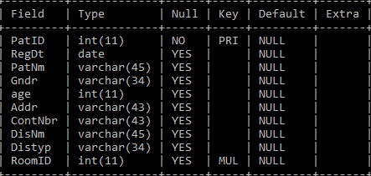

**Room information:**

This form is used to view details about a room by its room number. We can easily insert, update and delete records by clicking on the respective buttons. We can also load the data in the table.

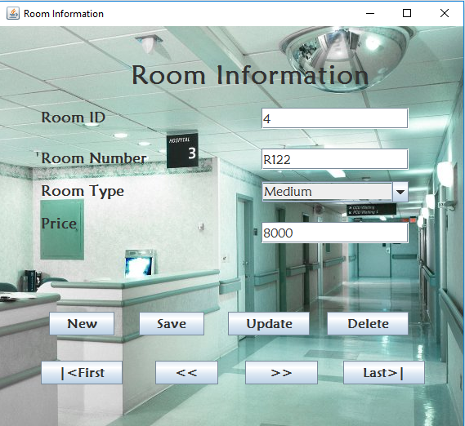

**Room information table-**

All the values entered in inward register are saved here and any manipulation like deleting or updating value will change the value in the table here.

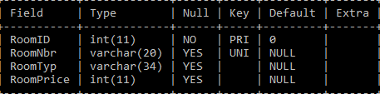

**Patient checkout:**

This form can be used to check out the patient from the hospital by his/her id and according to the room allocated and the days spent by the patient in the hospital the final checkout bill is calculated and displayed. From this we can see the patient details about payment and we generate their bills respectively.

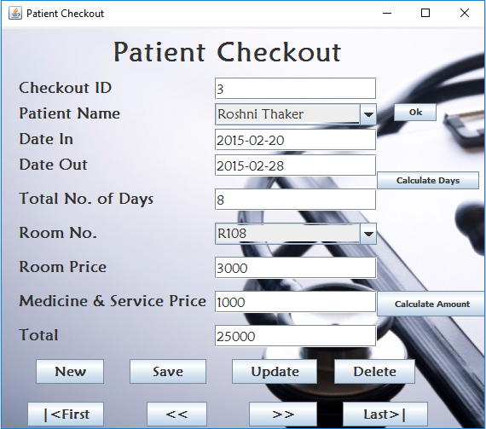

**Patient Checkout Table:**

All the values entered are saved here and any manipulation and bill creation is done here and will change the value in the table here.

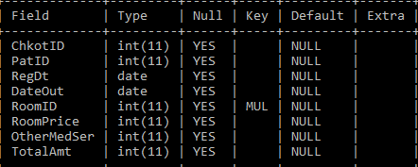

**Find Patient:**

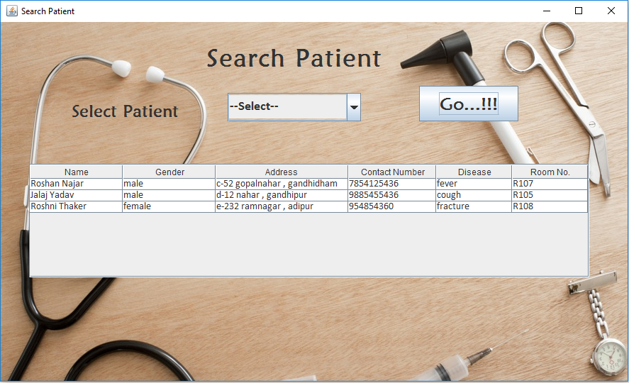

If we want to view details of particular patient, we can do so by selecting his/her name from the combo box control and clicking go button.

**Find Checkout Details:**

If we want to view details of checkout of particular patient, we can do so by selecting his/her name from the combo box control and clicking go button.

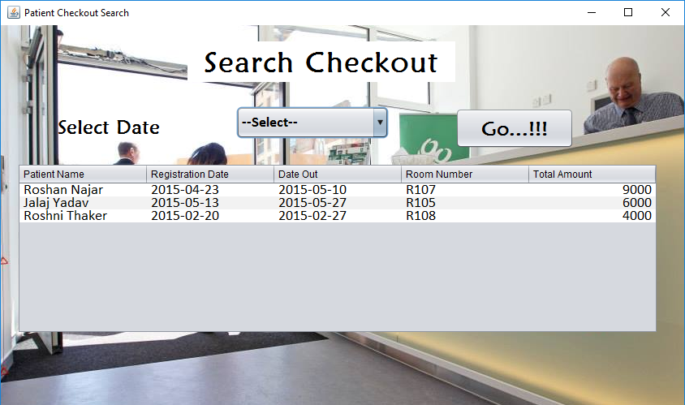

**Sample Coding**

**Generated Code:**

**Connection con=null;**

**Statement stmt=null;**

**Statement stmtroom=null;**

**String dr="java.sql.Driver";**

**String url="jdbc:mysql://localhost:3306/hms";**

**String usr="root";**

**String pwd="a";**

**String qry="";**

**ResultSet rs=null;**

**String Gendr="";**

**ResultSet rsRoom=null;**

**int rmid;**

**formWindowOpened:**

**this.setBounds(240, 120, 939 ,588);**

**try{ Class.forName(dr);**

**con=DriverManager.getConnection(url, usr, pwd);**

**stmt=con.createStatement();**

**qry="select RoomNbr from roominfo";**

**stmtroom=con.createStatement();**

**rsRoom=stmtroom.executeQuery(qry);**

**DefaultComboBoxModel rmnbr_mdl=(DefaultComboBoxModel)cmb_rmnbr.getModel();**

**while(rsRoom.next())**

**rmnbr_mdl.addElement(rsRoom.getString("RoomNbr"));**

**qry="select * from registration";**

**rs=stmt.executeQuery(qry);**

**rs.last();**

**t_ptid.setText(rs.getInt("PatID")+"");**

**t_dtin.setText(rs.getDate("RegDt")+"");**

**t_pnm.setText(rs.getString("PatNm"));**

**Gendr=rs.getString("Gndr");**

**if(Gendr.equals("male"))**

**rd_ml.setSelected(true);**

**else if(Gendr.equals("female"))**

**rd_fml.setSelected(true);**

**t_age.setText(rs.getInt("age")+"");**

**t_ad.append(rs.getString("Addr"));**

**t_cno.setText(rs.getString("ContNbr"));**

**t_disnm.setText(rs.getString("DisNm"));**

**t_distyp.setText(rs.getString("Distyp"));**

**qry="select RoomNbr,RoomTyp,RoomPrice from roominfo where RoomID="+rs.getInt("RoomID");**

**rsRoom=stmtroom.executeQuery(qry);**

**rsRoom.next();**

**cmb_rmnbr.setSelectedItem(rsRoom.getString("RoomNbr"));**

**cmb_rmtyp.setSelectedItem(rsRoom.getString("RoomTyp"));**

**t_rmpri.setText(rsRoom.getInt("RoomPrice")+"");**

**}catch(Exception e){**

**JOptionPane.showMessageDialog(rootPane, "failed" + e);}**

**Button New:**

**t_ptid.setText("");**

**t_dtin.setText("");**

**t_pnm.setText("");**

**t_age.setText("");**

**t_ad.setText("");**

**t_cno.setText("");**

**t_disnm.setText("");**

**t_distyp.setText("");**

**t_rmpri.setText("");**

**btngrp_gndr.clearSelection();**

**Button Save:**

**try{ qry="select * from registration";**

**rs=stmt.executeQuery(qry);**

**qry="select RoomID from roominfo where RoomNbr='"+cmb_rmnbr.getSelectedItem()+"'";**

**rsRoom=stmtroom.executeQuery(qry);**

**rsRoom.next();**

**rmid=rsRoom.getInt("RoomID");**

**if(rd_fml.isSelected())**

**Gendr="female";**

**else if(rd_ml.isSelected())**

**Gendr="male”;**

**qry="insert into registration values("+t_ptid.getText()+",'"+t_dtin.getText()+"' ,'"+t_pnm.getText()+"' ,'"+Gendr+"' ,"+ t_age.getText()+" ,'"+t_ad.getText() +"' ,'"+ t_cno.getText()+"','"+ t_disnm.getText()+"' ,'"+ t_distyp.getText()+"',"+rmid+")";**

**stmt.executeUpdate(qry);**

**JOptionPane.showMessageDialog(rootPane,"saved record ");**

**}catch(Exception e){ JOptionPane.showMessageDialog(rootPane,"falied"+"\n"+ e);}**

**Button Update:**

**try{qry="select RoomID from roominfo where RoomNbr='"+cmb_rmnbr.getSelectedItem()+"'";**

**rsRoom=stmtroom.executeQuery(qry);**

**rsRoom.next();**

**rmid=rsRoom.getInt("RoomID");**

**if(rd_fml.isSelected())**

**Gendr="female";**

**else if(rd_ml.isSelected())**

**Gendr="male";**

**qry="update registration set RegDt='"+t_dtin.getText()+"' , PatNm='"+t_pnm.getText()+"' , Gndr='"+Gendr+"' , age="+ t_age.getText()+" , Addr='"+t_ad.getText() +"' , ContNbr='"+ t_cno.getText()+"', DisNm='"+ t_disnm.getText()+"' , Distyp='"+ t_distyp.getText()+"',RoomID="+rmid+" where PatID="+t_ptid.getText();**

**stmt.executeUpdate(qry); JOptionPane.showMessageDialog(rootPane,"record updated");}catch(Exception e){JOptionPane.showMessageDialog(rootPane,"falied"+"\n"+ e);}**

**Button Delete:**

**try{ qry="delete from registration where PatID="+t_ptid.getText();**

**stmt.executeUpdate(qry);**

**JOptionPane.showMessageDialog(rootPane,"record deleted");**

**}catch(Exception**

**e){JOptionPane.showMessageDialog(rootPane,"failed"+"\n"+ e);}**

**Button First:**

**try{ rs.first();**

**t_ptid.setText(rs.getInt("PatID")+"");**

**t_dtin.setText(rs.getDate("RegDt")+"");**

**t_pnm.setText(rs.getString("PatNm"));**

**if(rs.getString("Gndr").equals("male"))**

**rd_ml.setSelected(true);**

**else if(rs.getString("Gndr").equals("female"))**

**rd_fml.setSelected(true);**

**t_age.setText(rs.getInt("age")+"");**

**t_ad.append(rs.getString("Addr"));**

**t_cno.setText(rs.getString("ContNbr"));**

**t_disnm.setText(rs.getString("DisNm"));**

**t_distyp.setText(rs.getString("Distyp"));**

**qry="select RoomNbr,RoomTyp,RoomPrice from roominfo where RoomID="+rs.getInt("RoomID");**

**rsRoom=stmtroom.executeQuery(qry);**

**rsRoom.next();**

**cmb_rmnbr.setSelectedItem(rsRoom.getString("RoomNbr"));**

**cmb_rmtyp.setSelectedItem(rsRoom.getString("RoomTyp"));**

**t_rmpri.setText(rsRoom.getInt("RoomPrice")+"");**

**}catch(Exception e){**

**JOptionPane.showMessageDialog(rootPane, "failed" + e);}**

**Button Previous:**

**try{ rs.previous();**

**t_ptid.setText(rs.getInt("PatID")+"");**

**t_dtin.setText(rs.getDate("RegDt")+"");**

**t_pnm.setText(rs.getString("PatNm"));**

**if(rs.getString("Gndr").equals("male"))**

**rd_ml.setSelected(true);**

**else if(rs.getString("Gndr").equals("female"))**

**rd_fml.setSelected(true);**

**t_age.setText(rs.getInt("age")+"");**

**t_ad.append(rs.getString("Addr"));**

**t_cno.setText(rs.getString("ContNbr"));**

**t_disnm.setText(rs.getString("DisNm"));**

**t_distyp.setText(rs.getString("Distyp"));**

**qry="select RoomNbr,RoomTyp,RoomPrice from roominfo where RoomID="+rs.getInt("RoomID");**

**rsRoom=stmtroom.executeQuery(qry);**

**rsRoom.next();**

**cmb_rmnbr.setSelectedItem(rsRoom.getString("RoomNbr"));**

**cmb_rmtyp.setSelectedItem(rsRoom.getString("RoomTyp"));**

**t_rmpri.setText(rsRoom.getInt("RoomPrice")+"");**

**}catch(Exception e){**

**JOptionPane.showMessageDialog(rootPane, "failed" + e);}**

**Button Next:**

**try{ rs.next();**

**t_ptid.setText(rs.getInt("PatID")+"");**

**t_dtin.setText(rs.getDate("RegDt")+"");**

**t_pnm.setText(rs.getString("PatNm"));**

**if(rs.getString("Gndr").equals("male"))**

**rd_ml.setSelected(true);**

**else if(rs.getString("Gndr").equals("female"))**

**rd_fml.setSelected(true);**

**t_age.setText(rs.getInt("age")+"");**

**t_ad.append(rs.getString("Addr"));**

**t_cno.setText(rs.getString("ContNbr"));**

**t_disnm.setText(rs.getString("DisNm"));**

**t_distyp.setText(rs.getString("Distyp"));**

**qry="select RoomNbr,RoomTyp,RoomPrice from roominfo where RoomID="+rs.getInt("RoomID");**

**rsRoom=stmtroom.executeQuery(qry);**

**rsRoom.next();**

**cmb_rmnbr.setSelectedItem(rsRoom.getString("RoomNbr"));**

**cmb_rmtyp.setSelectedItem(rsRoom.getString("RoomTyp"));**

**t_rmpri.setText(rsRoom.getInt("RoomPrice")+"");**

**}catch(Exception e){**

**JOptionPane.showMessageDialog(rootPane, "failed" + e);}**

**Button Last:**

**try{ rs.last();**

**t_ptid.setText(rs.getInt("PatID")+"");**

**t_dtin.setText(rs.getDate("RegDt")+"");**

**t_pnm.setText(rs.getString("PatNm"));**

**if(rs.getString("Gndr").equals("male"))**

**rd_ml.setSelected(true);**

**else if(rs.getString("Gndr").equals("female"))**

**rd_fml.setSelected(true);**

**t_age.setText(rs.getInt("age")+"");**

**t_ad.append(rs.getString("Addr"));**

**t_cno.setText(rs.getString("ContNbr"));**

**t_disnm.setText(rs.getString("DisNm"));**

**t_distyp.setText(rs.getString("Distyp"));**

**qry="select RoomNbr,RoomTyp,RoomPrice from roominfo where RoomID="+rs.getInt("RoomID");**

**rsRoom=stmtroom.executeQuery(qry);**

**rsRoom.next();**

**cmb_rmnbr.setSelectedItem(rsRoom.getString("RoomNbr"));**

**cmb_rmtyp.setSelectedItem(rsRoom.getString("RoomTyp"));**

**t_rmpri.setText(rsRoom.getInt("RoomPrice")+"");**

**}catch(Exception e){**

**JOptionPane.showMessageDialog(rootPane, "failed" + e);}**

**Button Ok:**

**try{ qry="select RoomTyp,RoomPrice from roominfo where RoomNbr='"+cmb_rmnbr.getSelectedItem().toString()+"'";**

**rsRoom=stmtroom.executeQuery(qry);**

**rsRoom.next();**

**cmb_rmtyp.setSelectedItem(rsRoom.getString("RoomTyp"));**

**t_rmpri.setText(rsRoom.getInt("RoomPrice")+"");**

**}catch(Exception e){JOptionPane.showMessageDialog(rootPane, "failed "+e);}**

**------------------------X-------------------------**